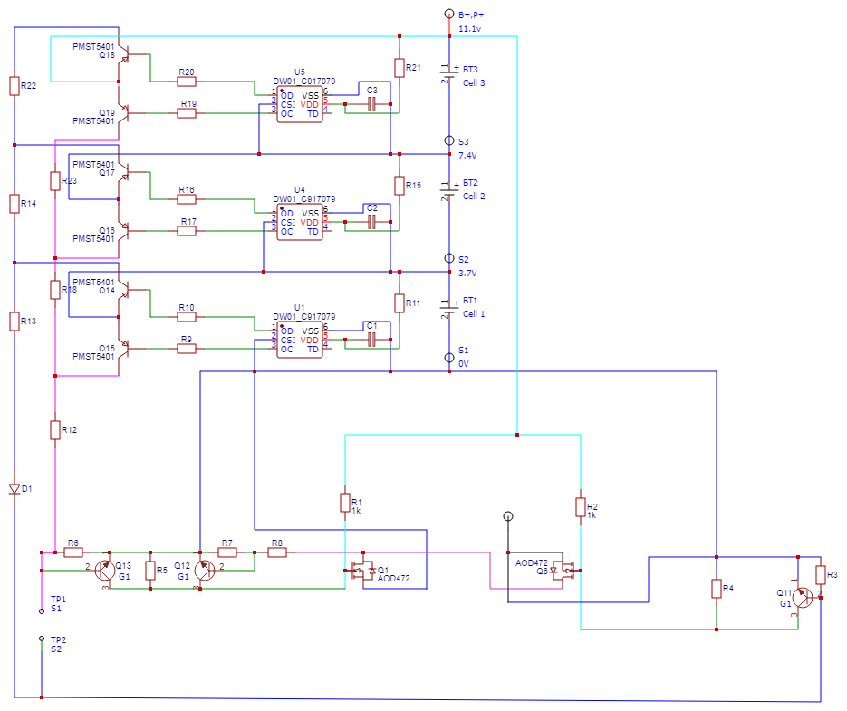

Main circuit

While charging, pin 3 of DW01 is in OFF state which allows the flow of charge from transistor Q15 which further turns ON the Q1 MOSFET allowing BT1 to charge. The ON state of MOSFETs is known as depletion state. The current check is done by CSI pin which pin 2 of DW01. As soon as the current limit is achieved, CSI pin signals the pin 3 of DW01 forcing it to switch ON due to which Q15 transistor and Q1 MOSFET goes into enhancement state which results in breaking the flow of charge to battery. Hence charging circuit opens.

While discharging or using, pin 1 of DW01 is in OFF state which allow the battery to drain as per the requirements due to the ON state of Q6 MOSFET but pin 2 keeps a check on current limit, how much current is drawn and the at time off short circuiting. When CSI pin or pin 2 check that current consummation is more then the limit or in case of short circuiting it signals the pin 1 of DW01 which results in pin 1 turning OFF both the electronic components i.e., Q14 transistor and Q6 MOSFETs or you can say both the components goes into enhancement state which results in breaking the flow of charge from battery. Hence discharging circuit opens.

This technique is same for n number of cell circuits connected to the main circuit.



Cell circuit